how to pass cmd line arg using eclipse

//right click -> Run As -> Run Configuration -> In Arguments Tab ->

//Pass the arguments and pass multiple args separating them by ' ' space

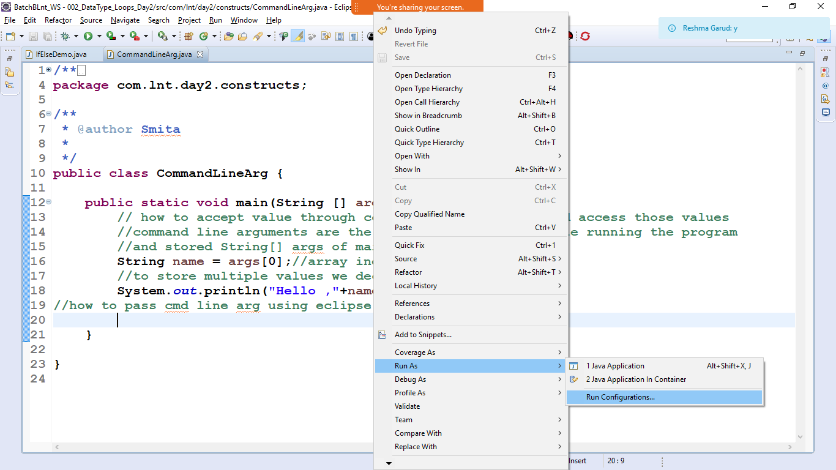

Pass the argument in the arguments tab

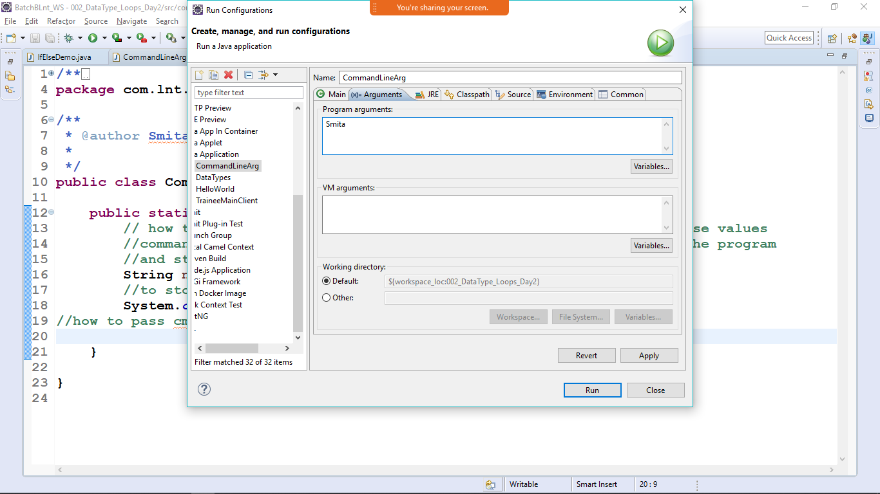

Apply-> run